Central Bucks High School South - Science National Honor Society

Membership for the Central Bucks South Science National Honor Society will open in the Fall of 2022. In order to apply to be a member of SNHS, students must meet the following criteria:

- Have a 3.7000 weighted Overall GPA
  - This can be found on the Student Copy of your transcript or in Infinite Campus
- Have a 4.0000 weighted Science GPA
  - See instructions below for calculating your Weighted Science GPA
- Enroll in at least 1 Honors and/or AP Science courses each year at CB South
- Actively participate in two Science Clubs at CB South
- Have no history of character/disciplinary issues

Verification of these criteria will be determined during the application process (the application can be downloaded from Mr. Testa’s Teacher Website).

Completed applications must be received by Mr. Testa no later Friday, September 16, 2022 at 3:00 pm.

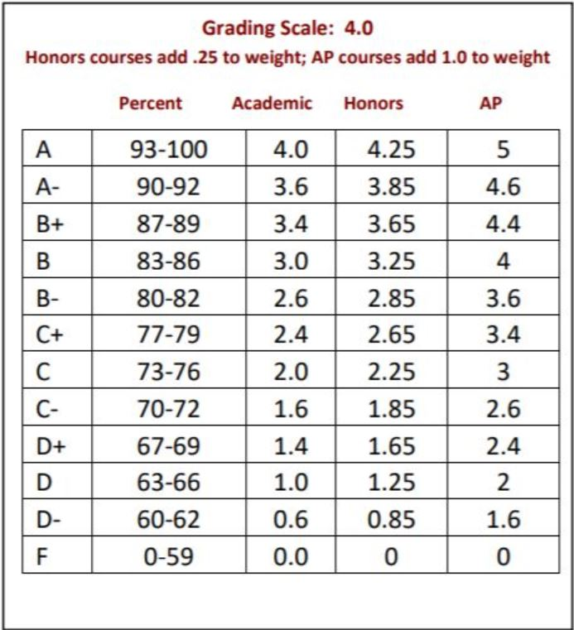

How do I calculate my weighted Science GPA?

Honors and AP courses are weighted according to this table.

You can calculate your weighted Science GPA by identifying the level of your science course and the final grade posted on your transcript/IC. See the examples below:

Example 1: You earn an A- in Honors Biology (3.85) and an A in Honors Chemistry (4.25)

(3.85 + 4.25) ÷ 2 = 4.05 is the weighted GPA…you qualify to apply

Example 2: You earn an A in Honors Biology (4.25) and a B+ in Honors Chemistry (3.65)

(4.25 + 3.65) ÷ 2 = 3.95 is the weighted GPA…you do not currently qualify to apply

Example 3: You earn an A- in Hon Biology, an A- in Hon Chemistry, and an A in AP Biology

(3.85 + 3.85 + 5.00) ÷ 3 = 4.233…you qualify to apply

